Primary Key Constraint

🌟 Definition
# Source: AI Source: Provided by: [Data Path: Persons Table -> ID Column: 1, Name_En Column: Motasem Essam] -> From: [ChatGPT] on [6/10/2026]
A Primary Key Constraint is a rule that ensures a column (or a combination of columns) uniquely identifies each row in a table.
A Primary Key is the main identifier for records in a table.

🎯 Purpose
# Source: AI Source: Provided by: [Data Path: Persons Table -> ID Column: 1, Name_En Column: Motasem Essam] -> From: [ChatGPT] on [6/10/2026]
The Primary Key is used to:
- Uniquely identify each record
- Prevent duplicate records
- Ensure data integrity
- Create relationships between tables
- Serve as a reference for foreign keys

🧠 Simple Example
# Source: AI Source: Provided by: [Data Path: Persons Table -> ID Column: 1, Name_En Column: Motasem Essam] -> From: [ChatGPT] on [6/10/2026]
Customers Table
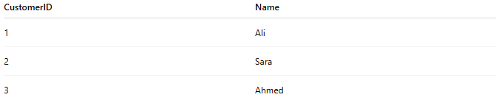
CustomerID | Name
1 | Ali
2 | Sara
3 | Ahmed
Here:
CustomerID
is the Primary Key.
Why?
Because each customer has a unique CustomerID.

🔢 Rules of a Primary Key
# Source: AI Source: Provided by: [Data Path: Persons Table -> ID Column: 1, Name_En Column: Motasem Essam] -> From: [ChatGPT] on [6/10/2026]
A Primary Key must:
1. Be Unique
No duplicate values are allowed.
✅ Valid
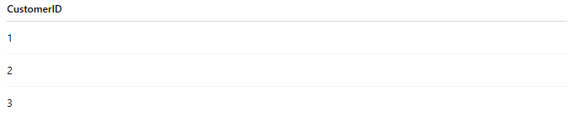
CustomerID
1
2
3

❌ Invalid
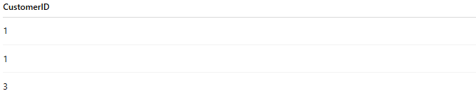
CustomerID
1
1
3
Duplicate value:
1
is not allowed.

2. Not Be NULL
Every record must have a Primary Key value.
✅ Valid
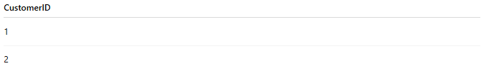
CustomerID
1
2

❌ Invalid
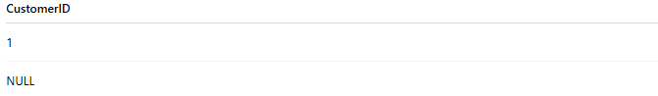
CustomerID
1
NULL
NULL values are not allowed.

3. Be Stable
The value should rarely change.
Good Example:

CustomerID
StudentID
EmployeeID
Bad Example:
Phone Number
Email Address
These can change over time.

📚 Real-World Examples
# Source: AI Source: Provided by: [Data Path: Persons Table -> ID Column: 1, Name_En Column: Motasem Essam] -> From: [ChatGPT] on [6/10/2026]
Customer Table
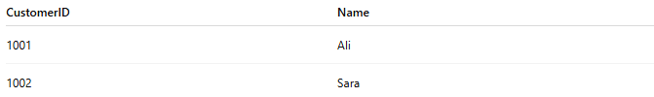
CustomerID | Name
1001 | Ali
1002 | Sara
Primary Key:
CustomerID

Student Table
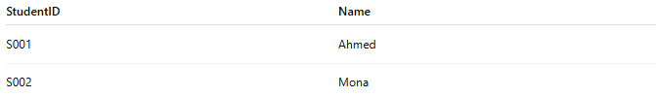
StudentID | Name
S001 | Ahmed
S002 | Mona
Primary Key:
StudentID

Product Table
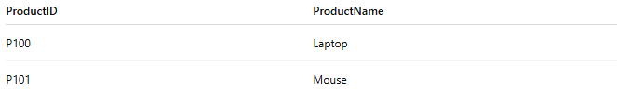
ProductID | ProductName
P100 | Laptop
P101 | Mouse
Primary Key:
ProductID

🗄️ SQL Example
# Source: AI Source: Provided by: [Data Path: Persons Table -> ID Column: 1, Name_En Column: Motasem Essam] -> From: [ChatGPT] on [6/10/2026]
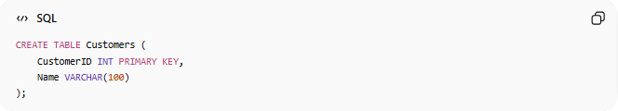
CREATE TABLE Customers (
CustomerID INT PRIMARY KEY,
Name VARCHAR(100)
);
Here:

PRIMARY KEY
creates the Primary Key Constraint.

📊 Primary Key in ER Diagrams
# Source: AI Source: Provided by: [Data Path: Persons Table -> ID Column: 1, Name_En Column: Motasem Essam] -> From: [ChatGPT] on [6/10/2026]
Primary keys are commonly underlined.
Example:
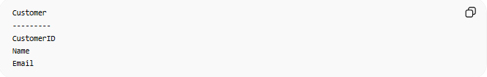
Customer
---------
CustomerID
Name
Email
Representation:
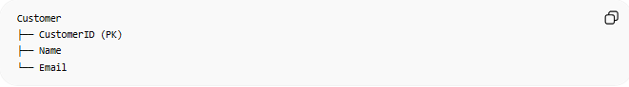
Customer
├── CustomerID (PK)
├── Name
└── Email

🔗 Primary Key and Foreign Key
# Source: AI Source: Provided by: [Data Path: Persons Table -> ID Column: 1, Name_En Column: Motasem Essam] -> From: [ChatGPT] on [6/10/2026]
Customers Table
CustomerID | Name
1 | Ali
Primary Key:
CustomerID

Orders Table
OrderID | CustomerID
101 | 1
CustomerID in Orders is a Foreign Key.
Relationship:
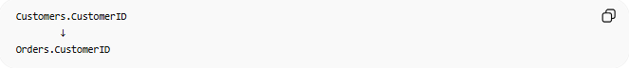
Customers.CustomerID
↓
Orders.CustomerID
The Primary Key in one table is often referenced by a Foreign Key in another.

🔑 Composite Primary Key
# Source: AI Source: Provided by: [Data Path: Persons Table -> ID Column: 1, Name_En Column: Motasem Essam] -> From: [ChatGPT] on [6/10/2026]
Sometimes a Primary Key consists of multiple columns.
Example:
Enrollment Table
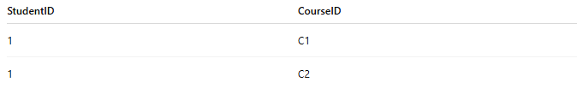
StudentID | CourseID
1 | C1
1 | C2
Neither column alone is unique.
Together:
(StudentID, CourseID)
form a Composite Primary Key.

SQL Example

CREATE TABLE Enrollment (
StudentID INT,
CourseID INT,
PRIMARY KEY (StudentID, CourseID)
);

⚠️ Primary Key vs Unique Constraint
# Source: AI Source: Provided by: [Data Path: Persons Table -> ID Column: 1, Name_En Column: Motasem Essam] -> From: [ChatGPT] on [6/10/2026]
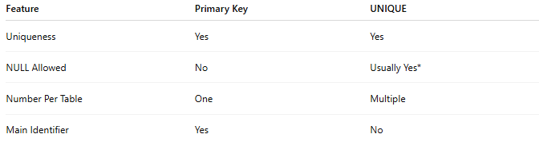
Feature | Primary Key | UNIQUE
Uniqueness | Yes | Yes
NULL Allowed | No | Usually Yes*
Number Per Table | One | Multiple
Main Identifier | Yes | No
* Database behavior may vary.

⚠️ Primary Key vs Foreign Key
# Source: AI Source: Provided by: [Data Path: Persons Table -> ID Column: 1, Name_En Column: Motasem Essam] -> From: [ChatGPT] on [6/10/2026]
Primary Key
Uniquely identifies a row.
Example:
CustomerID

Foreign Key
References a Primary Key in another table.
Example:
Orders.CustomerID

🌍 Real-World Example
# Source: AI Source: Provided by: [Data Path: Persons Table -> ID Column: 1, Name_En Column: Motasem Essam] -> From: [ChatGPT] on [6/10/2026]
National ID System
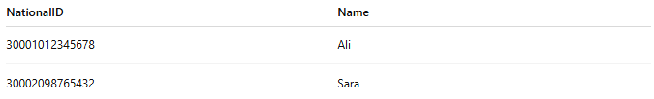
NationalID | Name
30001012345678 | Ali
30002098765432 | Sara
Primary Key:
NationalID
Every person has a unique identifier.

🧠 Simple Analogy
# Source: AI Source: Provided by: [Data Path: Persons Table -> ID Column: 1, Name_En Column: Motasem Essam] -> From: [ChatGPT] on [6/10/2026]
Think of a student ID card.
Student ID: S001
Many students may have the same:

Name
Age
City
But no two students have the same Student ID.
The Student ID uniquely identifies each student.
That is exactly what a Primary Key does in a database.

🧭 Summary
# Source: AI Source: Provided by: [Data Path: Persons Table -> ID Column: 1, Name_En Column: Motasem Essam] -> From: [ChatGPT] on [6/10/2026]
A Primary Key Constraint is a rule that ensures each record in a table has a unique, non-null identifier. It serves as the main way to identify rows, maintain data integrity, and establish relationships between tables through foreign keys. Common examples include CustomerID, StudentID, and ProductID.

